|  |  |  |  |
| --- | --- | --- | --- |
| **Team number** | 6 | **Section** | 3 |
| **Team Members** | 1. John Hoang 2. Isabel Pham 3. Ngan Luu 4. Anthony Nguyen | | |
| **Software Name** | JINA Studios | | |

## Introduction

* 1. Objective [5 Points]

The Technical Specification Document provides the design description (classes, behavior, and relationships of classes) of JINA Studios. JINA Studios is a desktop application that allows users access to interactive entertainment offline with several games to pick and choose from. The target audience for this product would be anyone who wants to play a collection of retro games. A basic understanding of video games would be required to understand general video game functions, objectives, and controls.

* 1. References [5 Points]  
     <https://stackoverflow.blog/2020/04/06/a-practical-guide-to-writing-technical-specs/>
  2. Acronyms, and abbreviations [5 Points]

|  |  |
| --- | --- |
| Item | an entity that provide a specific condition in a game to help user or provide tradeoffs in their next run/round |
| Hi-Score | Hi-Score means “High Score” |

## Software overview

2.1 Problem statement [5 Points]

The video games arcade had its root in 1971. Although it is not as popular as its golden time, with the development of gaming technology, arcade games have survived in several forms. Thus, our software will provide an offline arcade program. It is an interactive platform that allows users to not only entertain themselves with several retro games available but also to customize the environment by adding some extra features such as color setting and point trades.

Our application allows users to choose and play 4 retro games: Pong, Snake, Tetris and Block Breaker. For every round, users earn points. The highest point can be saved and sorted in order to create a competitive environment for users. With the corresponding amount of points, users can trade for items in the item shop which provide users the new and different experience to our application.

2.2 Scope [5 Points]

JINA Studios application targets users who are interested in playing retro games on their computers offline. Targeted users would be those who have an interest in offline games and users’ age would be any age older than 6. Since the application is written in English, users’ understood language would be English.

The key feature of our application is the option for games selection. With 4 games, our application will allow users to play 1 game at a time and save their score when they exit the game.

2.3 Technological Requirements [10 Points]

* Java for implementation of classes, interfaces, etc.
* JavaFX for user interface.
* Technology required:
* Java 8
* JavaFX
* Computer devices
* Windows 10 / Mac OS
* Eclipse

## Detailed Design

3.1 UML Class diagrams (for all classes) [20 Points]

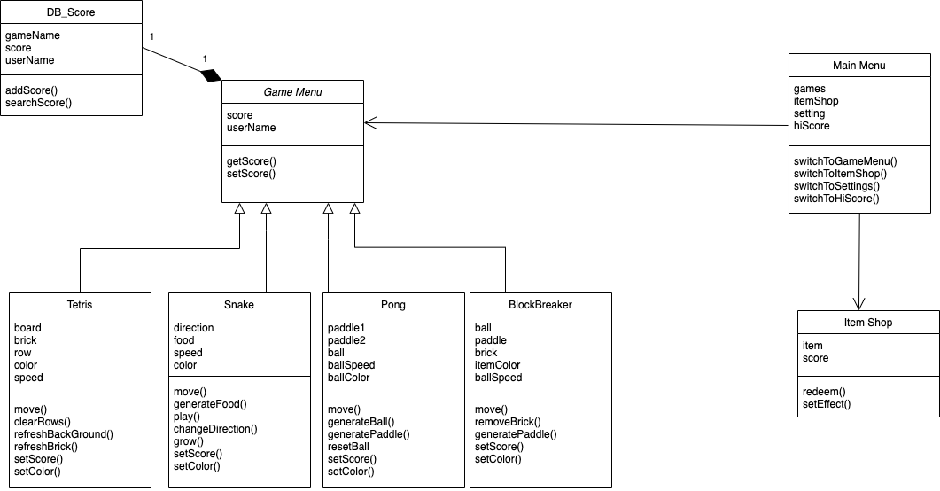

3.2 UML Sequence and/or state diagrams (at least one) [10 Points]

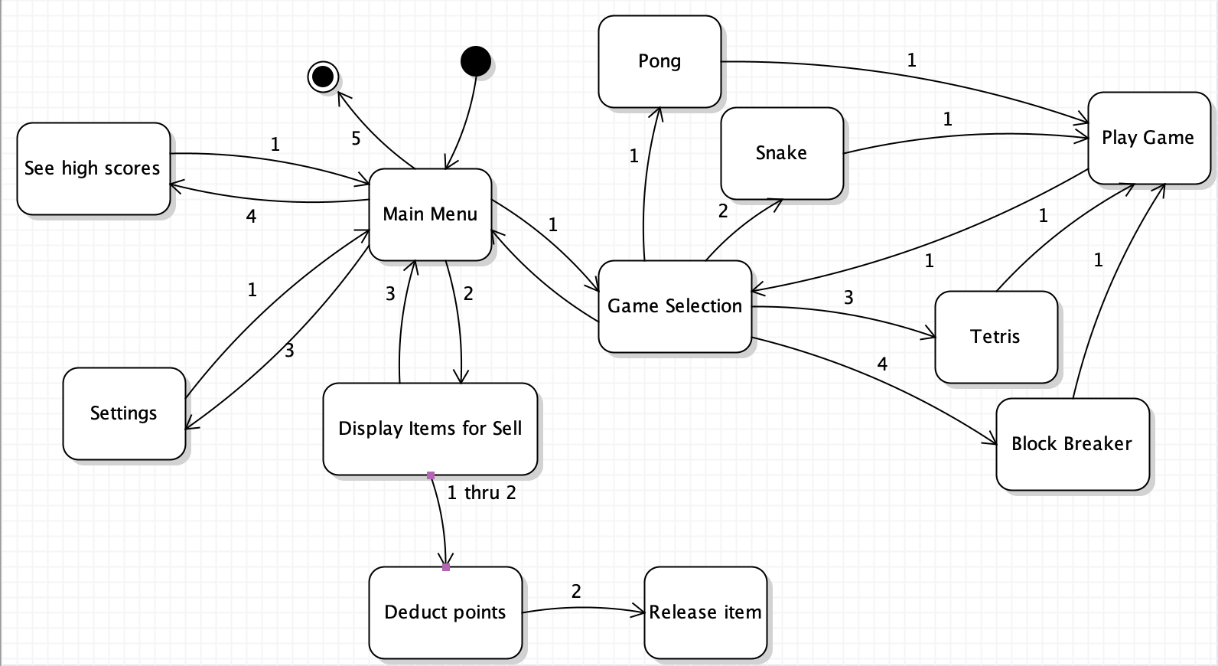

3.3 User Interface [15 Points]  
Note: “Game Block” is a section reserved for the game

